Assignment-2 (OSCN)
Enrolment ID: 2503B05121
Name: Chetti Rishika
Question:
Simulation of Distance Vector Routing using the Bellman-Ford Algorithm in C++.
Enter the number of nodes: 4
Enter the cost matrix (Enter 100 for INF):
0 2 5 1
2 0 3 2
5 3 0 3
1 2 3 0

Code:
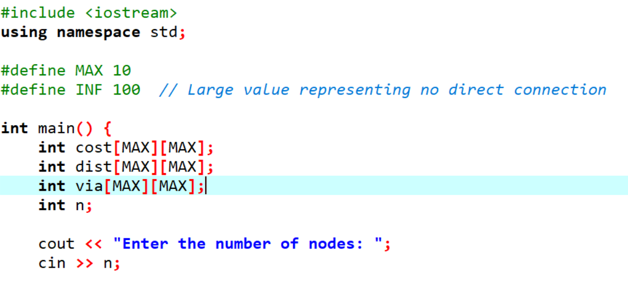
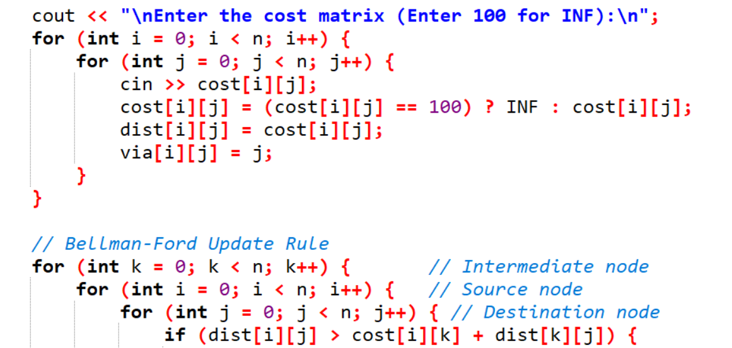
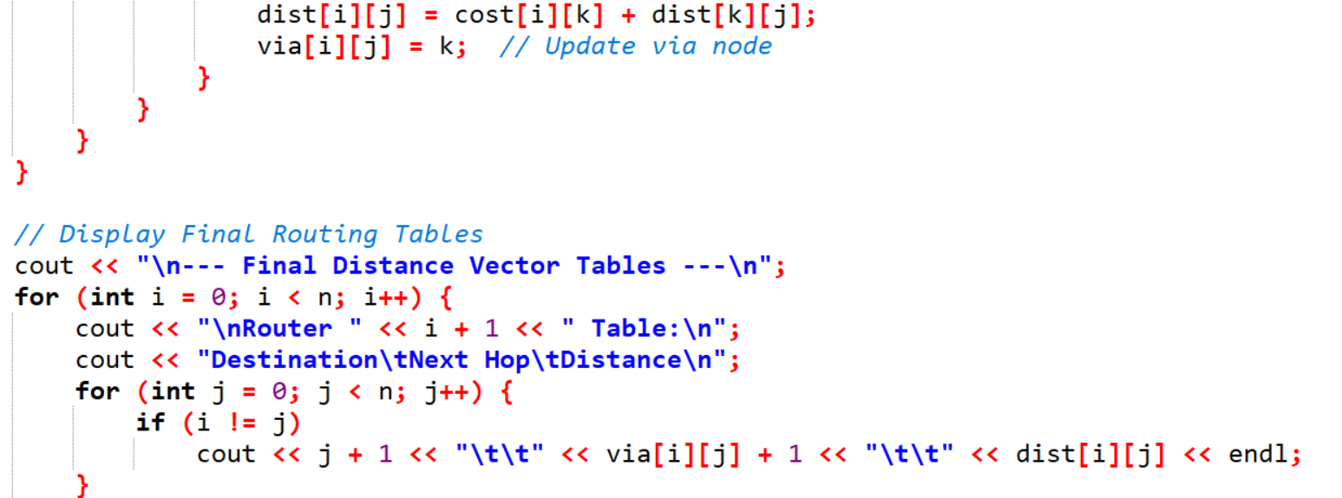
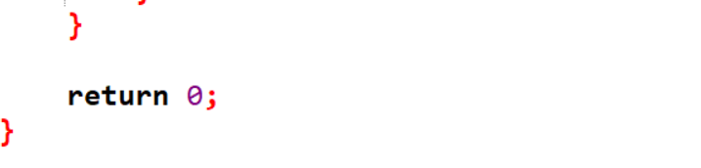

Output:

